INDUSTRY INTERNSHIP REPORT
On
EMPLOYEE MANAGEMENT SYSTEM

An internship report submitted in partial fulfillment of
requirements for the award of degree of
BACHELOR OF TECHNOLOGY IN
COMPUTER SCIENCE AND ENGINEERING

By
Mumman Kotamera Harshita (229X1A05E7)

Under the esteemed guidance of Sri. P. Praveen Yadav Assistant Professor Department of C.S.E.

Department of Computer Science and Engineering
G. PULLA REDDY ENGINEERING COLLEGE (Autonomous): KURNOOL
(Affiliated to JNTUA, ANANTAPURAMU)

2025 - 2026

Department of Computer Science and Engineering
G. PULLA REDDY ENGINEERING COLLEGE (Autonomous): KURNOOL
(Affiliated to JNTUA, ANANTAPURAMU)



CERTIFICATE

This is to certify that the internship titled ‘Plasmid’ is a bonafide record of work carried out by MUMMAN KOTAMERA HARSHITA (229X1A05E7) and the Internship report is submitted in partial fulfillment of requirements for the award of degree of Bachelor of Technology in Computer Science and Engineering.

Sri. P. Praveen Yadav Dr. N. Kasiviswanath
Assistant Professor, Professor and HOD,
Department of C.S.E, Department of C.S.E,
GPREC, Kurnool. GPREC, Kurnool.

INTERNSHIP DETAILS

Name of the College : G. Pulla Reddy Engineering College
Department : Computer Science and Engineering
Name of the Student : Mumman Kotamera Harshita
Register Number : 229X1A05E7
Name of the Faculty Guide : Sri. P. Praveen Yadav
Duration of the Internship : From: 15-12-2025 To: 15-03-2026
Name and address of the Organization : Plasmid Innovation of Technologies,1st floor, Featherlight The Address, Marathahalli,Bangalore, KA, 560103
Internship Domain : Web Development
Internship Title : Employee Management System
Internship Stipend : No Stipend
Date of Internship Report Submission : 18-04-2026

Internship Coordinator
Dr. B. Geetha Vani Professor
CSE Department GPREC

DECLARATION

I Mumman Kotamera Harshita, a student bearing the Roll No. 229X1A05E7, of the Department of Computer Science and Engineering, G. Pulla Reddy Engineering College, do hereby declare that the I have completed the mandatory internship titled Employee Management System using Spring technologies from 15-12-2025 to 15-03-2026 in Plasmid Innovation, Bangalore under the Faculty Guide ship of Sri. P. Praveen Yadav.

Student Signature and Date

CERTIFICATE FROM ORGANIZATION

This is to certify that Mumman Kotamera Harshita, a student bearing the Roll No. 219X1A05E7 of G. Pulla Reddy Engineering College underwent Internship in Plasmid
from 15-12-2025 to 15-03-2026. The overall performance of the Intern during her internship
is found to be good.



Authorized Signatory

INTERNSHIP COMPLETION CERTIFICATE

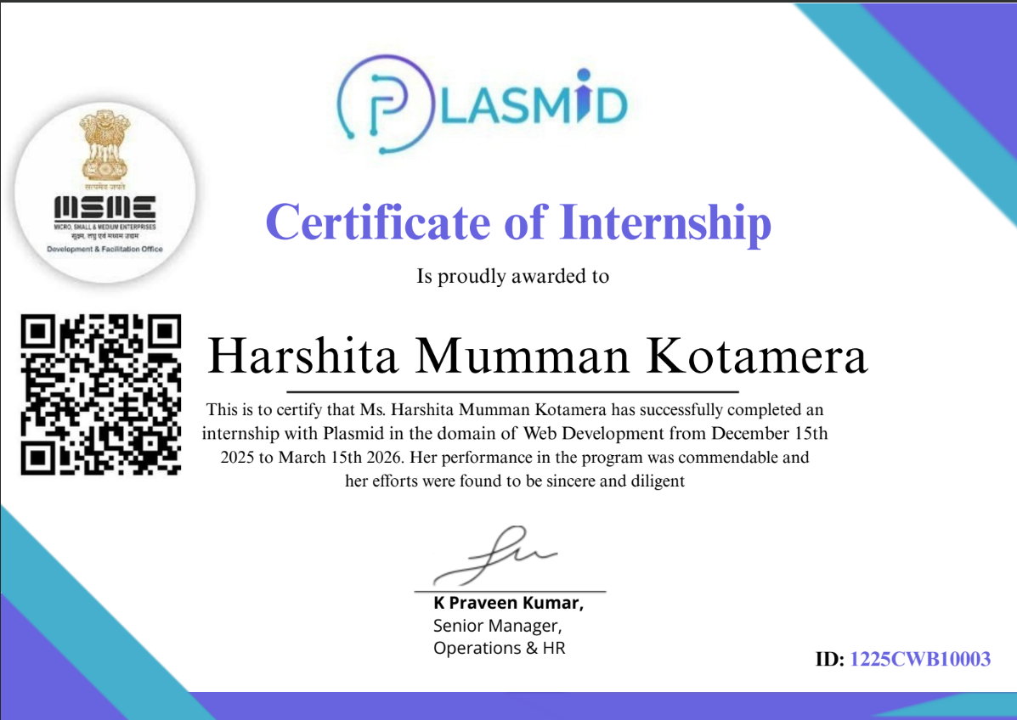

ACKNOWLEDGEMENT

I wish to express my deep sense of gratitude to my internal supervisor Sri. P. Praveen Yadav, Assistant Professor of Computer Science and Engineering Department, G. Pulla Reddy Engineering College.
My sincere thanks to our Internship Coordinator Dr. B. Geetha Vani, Professor of CSE for her immaculate guidance, constant encouragement and cooperation which have made possible to bring out this internship work.
I am thankful to our Head of the Department Dr. N. Kasiviswanath, for his whole hearted support and encouragement during the internship.
We are grateful to our Internship Dean Dr. Y. V. Siva Reddy and to our respected Principal Dr. B. Sreenivasa Reddy for providing requisite facilities and helping us in providing such a good environment.
I wish to convey my acknowledgements to all the staff members of the Computer Science and Engineering Department for giving the required information needed for my internship work.
Finally, I wish to thank all our friends and well-wishers who have helped me directly or indirectly during the course of this internship work.

TABLE OF CONTENTS

CHAPTER Page No
- INTRODUCTION
  - About the Internship Company 1
  - Offline Internship details 4
- WORK DONE DURING INTERNSHIP
  - About Domain 8
  - Technologies learnt during internship 16
- PROJECTS/MODULES COMPLETED
  - About Project 19
- ACTIVITY LOG 43
- CONCLUSION 48
- REFERENCES 50

INTRODUCTION

About the Internship Company/Organization:

The internship was carried out at Plasmid, a technology-focused training organization dedicated to bridging the gap between academic learning and industry requirements in the field of web development. Plasmid is committed to providing high-quality, structured training through a balanced approach that combines theoretical knowledge with practical, hands-on implementation. The program follows a modern and progressive curriculum that takes students from foundational concepts to advanced full-stack web development skills, ensuring they are industry-ready upon completion.

The training environment at Plasmid is designed to encourage interactive and collaborative learning. Students are guided through live sessions, project-based tasks, and real-world scenarios that help reinforce each concept as it is introduced. The curriculum is carefully structured to build skills incrementally — starting from how the internet works, progressing through HTML, CSS, JavaScript, Bootstrap, and Sass, and extending into back-end development with Node.js and database management with SQL.

One of the key strengths of Plasmid's training program is its emphasis on practical application. Rather than limiting learning to theory, every module includes exercises and mini-projects that challenge students to implement what they have learned. This approach develops not only technical proficiency but also problem-solving ability, logical thinking, and the confidence to work on real-world projects independently.

The internship was undertaken within this structured learning environment and culminated in the development of a fully functional EMI Calculator — an interactive front-end web application built using HTML, CSS, and JavaScript. This project served as a capstone that brought together all the front-end skills acquired during the training period.

1.2 Offline Internship details:

Training Phase

The internship was carried out at Plasmid, a technology-focused training organization dedicated to excellence in web development education, skill-building, and innovation, with a unique focus on integrating theoretical knowledge with practical implementation. The organization operates with the aim of producing technically competent professionals equipped with strong analytical and creative problem- solving skills.

Since its inception, Plasmid has been committed to providing high-quality education through a balanced approach that combines theoretical knowledge with practical applications. The organization follows a modern and flexible curriculum that emphasizes progressive learning, enabling students to explore diverse domains such as HTML, CSS, JavaScript, Bootstrap, Node.js, and Database Management. This approach ensures that students are not only academically proficient but also industry-ready and capable of addressing complex real-world challenges.

Plasmid's training environment is equipped with structured live sessions, hands-on project assignments, and guided mentorship. These facilities support a wide range of learning activities, allowing students to experiment, innovate, and develop cutting-edge solutions. The organization also promotes a collaborative and interactive learning environment where students actively engage in discussions, assignments, and technical projects, thereby creating opportunities for knowledge exchange and exposure to current industry trends.
One of the key strengths of Plasmid is its strong emphasis on practical application and project-based learning. The organization fosters a skill-driven culture by encouraging students to actively participate in real-world projects, complete assessments, and contribute to building functional web applications.
Various domains are actively covered, including Front-End Development, Back-End Development, Database Management, and Full-Stack Web Technologies.

The Department of Web Development at Plasmid is particularly known for its focus on emerging technologies and modern development methodologies. The curriculum covers fundamental and advanced topics such as HTML5, CSS3, JavaScript, DOM Manipulation, Bootstrap, Sass, jQuery, Node.js, RESTful APIs, and SQL. It also provides opportunities for students to engage in hands-on projects, assessments, and real-time development activities, thereby enhancing their technical expertise and practical understanding.

Program Structure

Duration: 12 weeks

Training Hours: Over 30 hours of instruction

Projects: 2 hands-on projects to apply learned skills
Certification: Industry-recognized certificate upon completion
Mentorship: Guidance from experienced professionals

WORK DONE DURING INTERNSHIP

2.1 About Domain
During my internship, I worked in the domain of Web Development, where I developed real-time web applications using frontend technologies. The internship focused on creating responsive user interfaces, implementing business logic using JavaScript, and building practical applications. Through this internship, I gained hands-on experience in developing interactive web-based tools and understanding real-world application workflows.

Project 1: Employee Management System

Project Description
The Employee Management System is a web-based application developed to manage employee records and department details efficiently. The system allows users to add, update, delete, and view employee information. The application was designed with a user-friendly interface and structured database integration.

Technologies Used
- React
- MySQL
- Spring Boot

Work Done
I designed the frontend interface including forms for adding and updating employee details. Navigation sections were implemented to access different modules of the system. Input validation was added to ensure accurate data entry.
On the backend, CRUD operations were implemented to manage employee records. APIs were used to handle data transfer between frontend and database. The database structure included tables for employees and departments. I tested the system to ensure smooth functionality and fixed errors during development.

This project improved my knowledge in full-stack development, database integration, and application architecture.

Project 2: EMI Calculator

Project Description
The EMI Calculator is a web-based application developed to calculate Equated Monthly Installments (EMI) for loans. The application allows users to enter loan amount, interest rate, and loan tenure, and calculates the monthly EMI instantly. The calculator provides a simple and interactive interface for financial calculations.

Technologies Used
- HTML5
- CSS3
- JavaScript

Work Done
I designed the user interface with input fields for loan amount, interest rate, and tenure. HTML was used to structure the layout, while CSS was applied for styling and responsive design. The layout was designed to be simple and easy to use.
JavaScript was used to implement the EMI calculation logic. Event listeners were added to capture user input and dynamically display the calculated EMI. Input validation was included to handle incorrect values and ensure accurate results.
The application was tested with different loan values to verify correctness. I also added responsive design features so the calculator works properly on mobile and desktop devices. This project helped me understand mathematical calculations in JavaScript and improve my frontend development skills.
2.2 Technologies learnt during internship

Skills Gained During Internship
- Web Application Development
- JavaScript DOM Manipulation
- Responsive Web Design
- CRUD Operations
- Problem Solving
- Debugging and Testing

Tasks Assigned During Internship
- Developed Employee Management System
- Built EMI Calculator using JavaScript
- Implemented responsive UI design
- Tested application functionality
- Debugged errors and improved performance

PROJECTS COMPLETED

3.1 Project – 1: Employee Management System

Abstract
The Employee Management System is a web-based application developed to efficiently manage employee and department details within an organization. The system provides functionalities such as adding new employees, updating existing records, deleting employee data, and viewing employee information. The main objective of this project is to simplify employee data management and improve accessibility through a user-friendly interface. The application ensures structured data storage and quick retrieval of information, making it useful for organizations of any size.

Introduction
Managing employee information manually is time-consuming and prone to errors. The Employee Management System was developed to overcome these challenges by providing an automated solution. This project allows administrators to perform CRUD operations on employee data and maintain department-wise information. The system was designed using web technologies to ensure responsiveness and ease of use.

The application consists of different modules such as adding employees, updating employee details, deleting records, and displaying employee lists. Database integration was implemented to store data securely. This project helped in understanding the real-time implementation of web development concepts and improved knowledge of frontend and backend interaction.

Project Employee Management System:

package net.javaguides.ems.controller;

import lombok.AllArgsConstructor;
import net.javaguides.ems.dto.DepartmentDto;
import net.javaguides.ems.service.DepartmentService; import org.springframework.http.HttpStatus;
import org.springframework.http.ResponseEntity; import org.springframework.web.bind.annotation.*;

import java.util.List;

@CrossOrigin("*") @AllArgsConstructor @RestController @RequestMapping("/api/departments") public class DepartmentController {

private DepartmentService departmentService;
// Build Create or Add Department REST API @PostMapping
public ResponseEntity<DepartmentDto> createDepartment(@RequestBody DepartmentDto departmentDto){
DepartmentDto department = departmentService.createDepartment(departmentDto); return new ResponseEntity<>(department, HttpStatus.CREATED);
}

// Build Get Department REST API

@GetMapping("{id}")
public ResponseEntity<DepartmentDto> getDepartmentById(@PathVariable("id") Long departmentId){
DepartmentDto departmentDto = departmentService.getDepartmentById(departmentId); return ResponseEntity.ok(departmentDto);
}

// Build Get All Departments REST API @GetMapping
public ResponseEntity<List<DepartmentDto>> getAllDepartments(){ List<DepartmentDto> departments = departmentService.getAllDepartments(); return ResponseEntity.ok(departments);
}

// Build Update Department REST API @PutMapping("{id}")
public ResponseEntity<DepartmentDto> updateDepartment(@PathVariable("id") Long departmentId,
@RequestBody DepartmentDto updatedDepartment){ DepartmentDto departmentDto = departmentService.updateDepartment(departmentId,
updatedDepartment);
return ResponseEntity.ok(departmentDto);
}

// Build Delete Department REST API @DeleteMapping("{id}")
public ResponseEntity<String> deleteDepartment(@PathVariable("id") Long departmentId){ departmentService.deleteDepartment(departmentId);
return ResponseEntity.ok("Department deleted successfully!.");
}
}

package net.javaguides.ems.controller;

import lombok.AllArgsConstructor;
import net.javaguides.ems.dto.EmployeeDto;

import net.javaguides.ems.service.EmployeeService; import org.springframework.http.HttpStatus;
import org.springframework.http.ResponseEntity; import org.springframework.web.bind.annotation.*;

import java.util.List;

@CrossOrigin("*") @AllArgsConstructor @RestController @RequestMapping("/api/employees") public class EmployeeController {

private EmployeeService employeeService;

// Build Add Employee REST API @PostMapping
public ResponseEntity<EmployeeDto> createEmployee(@RequestBody EmployeeDto employeeDto){
EmployeeDto savedEmployee = employeeService.createEmployee(employeeDto); return new ResponseEntity<>(savedEmployee, HttpStatus.CREATED);
}

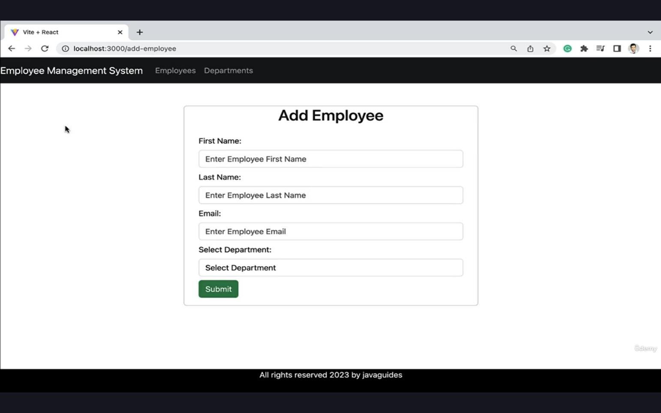

Figure 3.1.1 Adding new Employee to the Database

// Build Get Employee REST API @GetMapping("{id}")
public ResponseEntity<EmployeeDto> getEmployeeById(@PathVariable("id") Long employeeId){ EmployeeDto employeeDto = employeeService.getEmployeeById(employeeId);
return ResponseEntity.ok(employeeDto);
}

// Build Get All Employees REST API @GetMapping
public ResponseEntity<List<EmployeeDto>> getAllEmployees(){ List<EmployeeDto> employees = employeeService.getAllEmployees(); return ResponseEntity.ok(employees);

}

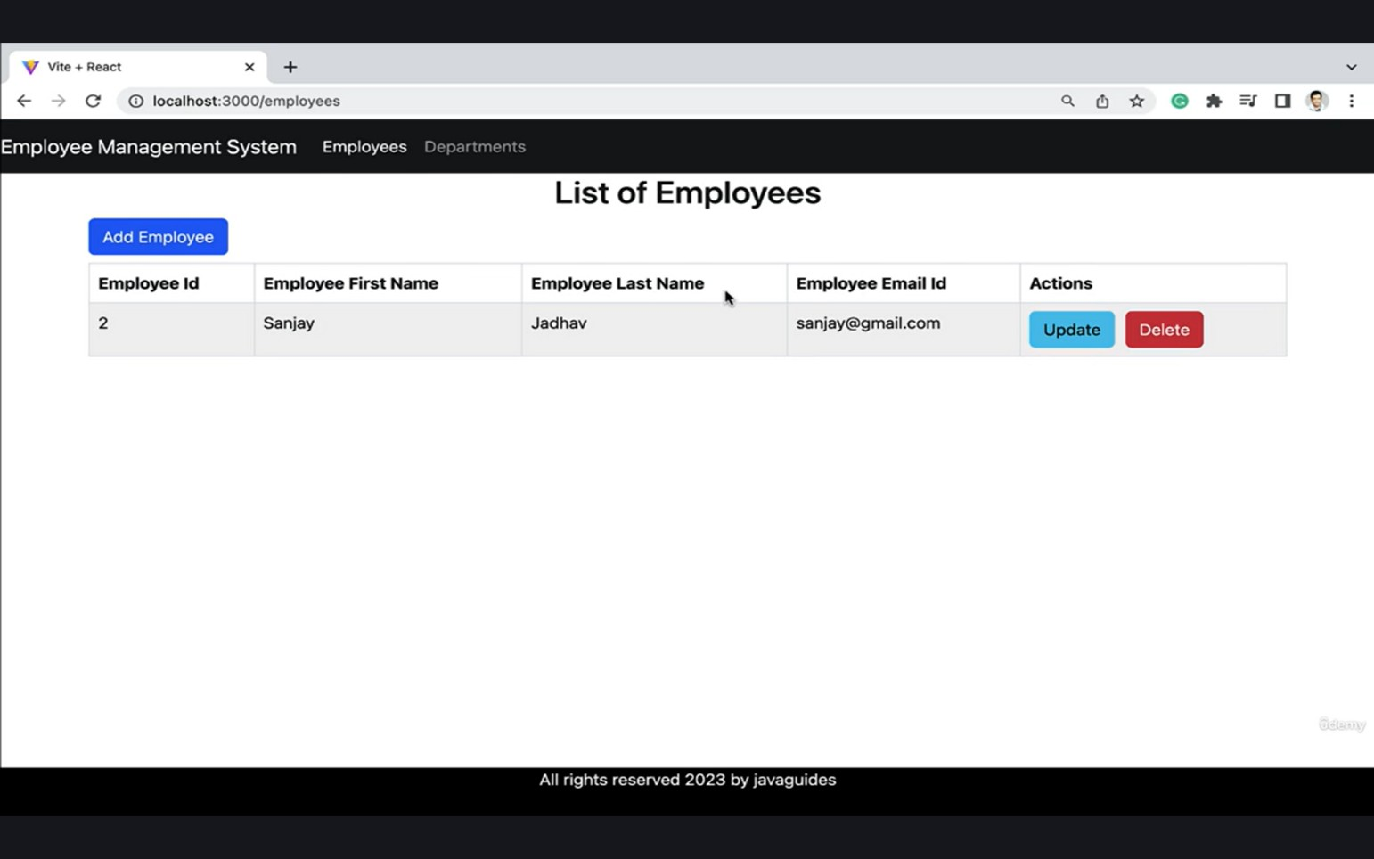

Figure 3.1.2 List all the Employees in the Database

// Build Update Employee REST API @PutMapping("{id}")
public ResponseEntity<EmployeeDto> updateEmployee(@PathVariable("id") Long employeeId,
@RequestBody EmployeeDto updatedEmployee){
EmployeeDto employeeDto = employeeService.updateEmployee(employeeId, updatedEmployee); return ResponseEntity.ok(employeeDto);
}

// Build Delete Employee REST API @DeleteMapping("{id}")
public ResponseEntity<String> deleteEmployee(@PathVariable("id") Long employeeId){ employeeService.deleteEmployee(employeeId);
return ResponseEntity.ok("Employee deleted successfully!.");
}
}
package net.javaguides.ems.dto;

import lombok.AllArgsConstructor; import lombok.Getter;
import lombok.NoArgsConstructor; import lombok.Setter;

@Getter @Setter
@NoArgsConstructor @AllArgsConstructor
public class DepartmentDto { private Long id;
private String departmentName; private String departmentDescription;
}

package net.javaguides.ems.entity;

import jakarta.persistence.*;
import lombok.AllArgsConstructor; import lombok.Getter;
import lombok.NoArgsConstructor; import lombok.Setter;

@Getter @Setter
@NoArgsConstructor @AllArgsConstructor @Entity
@Table(name = "departments") public class Department {

@Id
@GeneratedValue(strategy = GenerationType.IDENTITY) private Long id;

@Column(name = "department_name") private String departmentName;

@Column(name = "department_description") private String departmentDescription;
}
package net.javaguides.ems.entity;

import jakarta.persistence.*;
import lombok.AllArgsConstructor; import lombok.Getter;
import lombok.NoArgsConstructor; import lombok.Setter;

@Getter @Setter

@NoArgsConstructor @AllArgsConstructor @Entity
@Table(name = "employees") public class Employee {

@Id
@GeneratedValue(strategy = GenerationType.IDENTITY) private Long id;

@Column(name = "first_name") private String firstName;

@Column(name = "last_name") private String lastName;

@Column(name = "email_id", nullable = false, unique = true) private String email;

@ManyToOne(fetch = FetchType.LAZY) @JoinColumn(name = "department_id") private Department department;
}

3.2 Project – 2: EMI Calculator

Abstract
The EMI Calculator is a web-based financial application developed to calculate the Equated Monthly Installment (EMI) for loans. The calculator allows users to input loan amount, interest rate, and tenure, and instantly provides the EMI result. The main objective of this project is to create a simple and interactive tool that helps users estimate their monthly loan payments. The application uses JavaScript for performing calculations and provides accurate results in real time.

Introduction
Calculating loan EMI manually can be complex and time-consuming. The EMI Calculator project was developed to automate this process and provide quick results. The application provides an easy-to-use interface where users can enter required loan details and get the EMI instantly.
The project was implemented using HTML for structure, CSS for styling, and JavaScript for calculation logic. Input validation was added to ensure proper data entry. The calculator dynamically updates the
EMI based on user inputs. This project helped in understanding mathematical implementation using JavaScript and improved skills in developing interactive web applications.
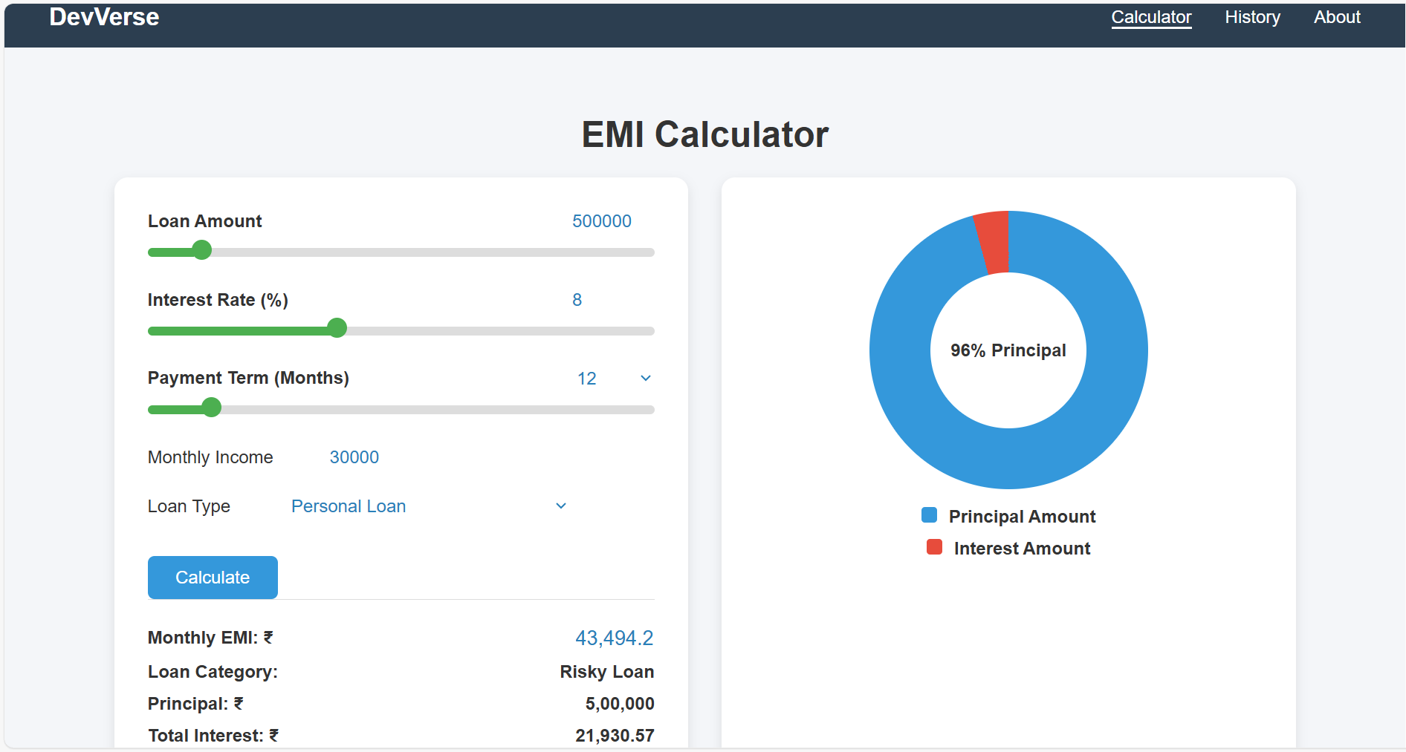

Figure 3.2.1 EMI calculator with donut chart for readability

Code Implementation: Project EMI Calculator:
const loanAmountInput = document.getElementById('loanAmount');
const interestRateInput = document.getElementById('interestRate');
const tenureInput = document.getElementById('tenure');

const loanAmountDisplay = document.getElementById('loanAmountDisplay');
const interestRateDisplay = document.getElementById('interestRateDisplay');
const tenureDisplay = document.getElementById('tenureDisplay');

const incomeInput = document.getElementById('income');
const loanTypeSelect = document.getElementById('loanType');

const monthlyEMIDisplay = document.getElementById('monthlyEMI');
const principalAmountDisplay = document.getElementById('principalAmount');
const totalInterestDisplay = document.getElementById('totalInterest');
const loanCategoryDisplay = document.getElementById('loanCategory');

const chart = document.getElementById("emiChart");
const chartCenter = document.getElementById("chartCenter");
const historyBody = document.getElementById("historyBody");

const tabCalculator = document.getElementById("tabCalculator");
const tabHistory = document.getElementById("tabHistory");
const tabAbout = document.getElementById("tabAbout");

const calculatorSection = document.getElementById("emicalculator");
const historySection = document.getElementById("history");
const aboutSection = document.getElementById("about");

let lastCalculatedData = null;

/* ------------------ Populate Tenure Dropdown ------------------ */
for (let i = 6; i <= 60; i++) {
const option = document.createElement("option");
option.value = i;
option.textContent = i;
tenureDisplay.appendChild(option);
}
tenureDisplay.value = tenureInput.value;

/* ------------------ TAB SWITCH ------------------ */
tabCalculator.onclick = (e) => { e.preventDefault(); showCalculator(); };
tabHistory.onclick = (e) => { e.preventDefault(); showHistory(); };
tabAbout.onclick = (e) => { e.preventDefault(); showAbout(); };

function showCalculator() {
calculatorSection.classList.add("active");
historySection.classList.remove("active");
aboutSection.classList.remove("active");

tabCalculator.classList.add("active");
tabHistory.classList.remove("active");
tabAbout.classList.remove("active");
}

function showHistory() {
historySection.classList.add("active");
calculatorSection.classList.remove("active");
aboutSection.classList.remove("active");

tabHistory.classList.add("active");
tabCalculator.classList.remove("active");
tabAbout.classList.remove("active");
}

function showAbout() {
aboutSection.classList.add("active");
calculatorSection.classList.remove("active");
historySection.classList.remove("active");

tabAbout.classList.add("active");
tabCalculator.classList.remove("active");
tabHistory.classList.remove("active");
}

/* ------------------ SLIDER SYNC ------------------ */
function updateSliderFill(slider) {
const value = (slider.value - slider.min) / (slider.max - slider.min) * 100;
slider.style.background =
`linear-gradient(to right, #4CAF50 ${value}%, #ddd ${value}%)`;
}

function sync(range, number) {

// When slider moves → update number field
range.addEventListener("input", () => {
number.value = range.value;
updateSliderFill(range);
});

// When typing → update slider (without forcing min/max immediately)
number.addEventListener("input", () => {
const val = parseFloat(number.value);

if (!isNaN(val)) {
range.value = val;
updateSliderFill(range);
}
});

// When user leaves input field → enforce limits
number.addEventListener("blur", () => {
let val = parseFloat(number.value);

if (isNaN(val)) val = parseFloat(range.min);

if (val < parseFloat(range.min)) val = parseFloat(range.min);
if (val > parseFloat(range.max)) val = parseFloat(range.max);

number.value = val;
range.value = val;
updateSliderFill(range);
});

updateSliderFill(range);
}

sync(loanAmountInput, loanAmountDisplay);
sync(interestRateInput, interestRateDisplay);

tenureInput.oninput = () => {
tenureDisplay.value = tenureInput.value;
updateSliderFill(tenureInput);
};

tenureDisplay.onchange = () => {
tenureInput.value = tenureDisplay.value;
updateSliderFill(tenureInput);
};

updateSliderFill(tenureInput);

/* ------------------ CALCULATE EMI ------------------ */
document.getElementById("calculateBtn").onclick = calculateEMI;

function calculateEMI() {

const P = parseFloat(loanAmountInput.value);
const rate = parseFloat(interestRateInput.value);
const months = parseInt(tenureInput.value);
const income = parseFloat(incomeInput.value);

// Validation
if (isNaN(P) || P <= 0) {
alert("Enter valid Loan Amount");
return;
}

if (isNaN(rate) || rate <= 0) {
alert("Interest rate must be greater than 0");
return;
}

if (isNaN(months) || months < 6) {
alert("Tenure must be at least 6 months");
return;
}

if (isNaN(income) || income <= 0) {
alert("Enter valid Monthly Income");
return;
}

const r = rate / 12 / 100;

let emi;
if (r === 0) {
emi = P / months;
} else {
emi = (P * r * Math.pow(1 + r, months)) /
(Math.pow(1 + r, months) - 1);
}

if (!isFinite(emi)) {
alert("Calculation error. Check inputs.");
return;
}

const total = emi * months;
const interest = total - P;

monthlyEMIDisplay.value =
Number(emi.toFixed(2)).toLocaleString('en-IN');

principalAmountDisplay.textContent =
P.toLocaleString('en-IN');

totalInterestDisplay.textContent =
Number(interest.toFixed(2)).toLocaleString('en-IN');

/* ----- Loan Category ----- */
const emiPercent = (emi / income) * 100;

let category;
if (emiPercent <= 30) category = "Safe Loan";
else if (emiPercent <= 50) category = "Moderate Loan";
else category = "Risky Loan";

loanCategoryDisplay.textContent = category;

drawChart(P, interest);

lastCalculatedData = {
loan: P.toLocaleString('en-IN'),
rate: rate,
months: months,
income: income.toLocaleString('en-IN'),
type: loanTypeSelect.value,
emi: monthlyEMIDisplay.value,
category: category
};
}

/* ------------------ CHART ------------------ */
function drawChart(principal, interest) {
const total = principal + interest;
const angle = (principal / total) * 360;

chart.style.background = `conic-gradient(
#3498db 0deg,
#3498db ${angle}deg,
#e74c3c ${angle}deg,
#e74c3c 360deg
);

chartCenter.textContent =
Math.round((principal / total) * 100) + "% Principal";
}

/* ------------------ SAVE HISTORY ------------------ */
document.getElementById("save").onclick = () => {

if (!lastCalculatedData) {
alert("Please calculate EMI before saving.");
return;
}

let historyData =
JSON.parse(localStorage.getItem("emiHistory")) || [];

historyData.push(lastCalculatedData);

localStorage.setItem(
"emiHistory",
JSON.stringify(historyData)
);

addRow(lastCalculatedData);
showHistory();
};

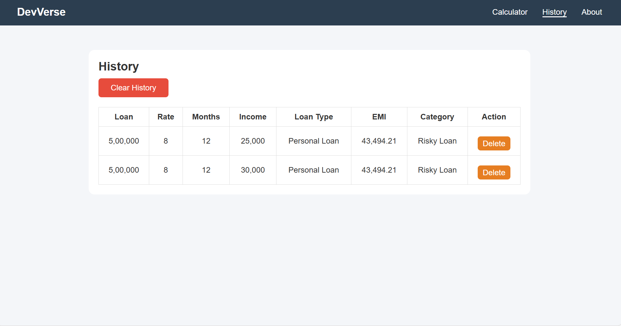

Figure 3.2.2 History table to view all the previous calculations

/* ------------------ LOAD HISTORY ------------------ */
window.onload = () => {
const historyData =
JSON.parse(localStorage.getItem("emiHistory")) || [];

historyData.forEach(addRow);
};

function addRow(item) {

const row = document.createElement("tr");

row.innerHTML = `
<td>${item.loan}</td>
<td>${item.rate}</td>
<td>${item.months}</td>
<td>${item.income}</td>
<td>${item.type}</td>
<td>${item.emi}</td>
<td>${item.category}</td>
<td><button class="delete-btn">Delete</button></td>
row.querySelector(".delete-btn").onclick = () => {
row.remove();
updateStorage();
};

historyBody.appendChild(row);
}

document.getElementById("clearHistory").onclick = () => {
historyBody.innerHTML = "";
localStorage.removeItem("emiHistory");
};

function updateStorage() {

const rows = historyBody.querySelectorAll("tr");
let data = [];

rows.forEach(r => {
const c = r.querySelectorAll("td");
data.push({

loan: c[0].textContent,
rate: c[1].textContent,
months: c[2].textContent,
income: c[3].textContent,
type: c[4].textContent,
emi: c[5].textContent,
category: c[6].textContent
});
});

localStorage.setItem("emiHistory", JSON.stringify(data));
}

- ACTIVITY LOG FOR THE WEEK

Weeks | Description of the weekly activity | Learning Outcome | Person  In charge Signature
Week 1 | Attended internship orientation session, understood organization workflow, discussed project guidelines, and installed required software such as code editor and browser tools. | Gained understanding of internship objectives, development environment setup, and basic workflow of web development projects.
Week 2 | Learned HTML fundamentals including tags, forms, tables, and semantic elements. Created basic static web pages for practice. | Acquired knowledge of HTML structure and ability to design simple webpages.
Week 3 | Studied advanced HTML5 concepts, semantic elements, and form controls. Started designing sample web layouts. | Learned advanced HTML concepts and improved page structuring skills.
Week 4 | Learned CSS fundamentals including selectors, box model, layout, background, text styling, and animations. | Acquired skills in styling webpages using CSS.
Week 5 | Studied CSS Grid and layout design. Introduction to Bootstrap and created responsive layouts using Bootstrap components. | Learned responsive design and layout management.
Week 6 | Created sample portfolio webpage with header, footer, hero section, and responsive design using Bootstrap. | Gained experience in building responsive web pages.

Weeks | Description of the weekly activity | Learning Outcome | Person  In charge  Signature
Week 7 | Introduction to JavaScript, variables, data types, operators, control statements, and basic calculator implementation. | Learned JavaScript fundamentals and logic building.
Week 8 | Studied functions, arrays, objects, loops, and DOM manipulation. Implemented interactive elements using JavaScript. | Improved DOM manipulation and dynamic webpage development skills.
Week 9 | Learned JavaScript OOP concepts, constructors, inheritance, and events handling. Worked on background generator exercise. | Gained knowledge of advanced JavaScript concepts.
Week 10 | Introduction to jQuery and Node.js. Learned modules, Express framework, and RESTful APIs. | Understood backend basics and server-side development.
Week 11 | Studied Database and SQL concepts including create table, insert, update, delete, and join operations. | Learned database management and SQL queries.
Week 12 | Major project discussion and development of Employee Management System and EMI Calculator. Final testing and documentation preparation. | Gained practical experience in real-time project development and documentation.

CONCLUSION

During the internship, I successfully completed two projects: Employee Management System and EMI Calculator. These projects helped me apply the concepts learned during the training in a practical manner. While working on the Employee Management System, I gained experience in designing user interfaces, implementing CRUD operations, and managing employee data efficiently. This project improved my understanding of structured web application development and responsive design.
The EMI Calculator project helped me implement mathematical logic using JavaScript and develop an interactive user interface. I learned how to handle user inputs, perform dynamic calculations, and display results in real time. This project enhanced my skills in DOM manipulation and frontend development.
Overall, working on these two projects improved my technical knowledge, problem-solving ability, and debugging skills. The internship provided hands-on experience in web development and helped me understand real-time project implementation. It also increased my confidence in developing user-friendly and responsive web applications.

REFERENCES

- https://spring.io/projects/spring-boot
- https://spring.io/projects/spring-data-jpa
- https://react.dev
- https://dev.mysql.com/doc
- https://developer.mozilla.org/en-US/docs/Web/JavaScript
- https://projectlombok.org
- https://restfulapi.net
- https://www.w3schools.com

